Dataset review:

<https://www.kaggle.com/datasets/shashwatwork/web-page-phishing-detection-dataset>

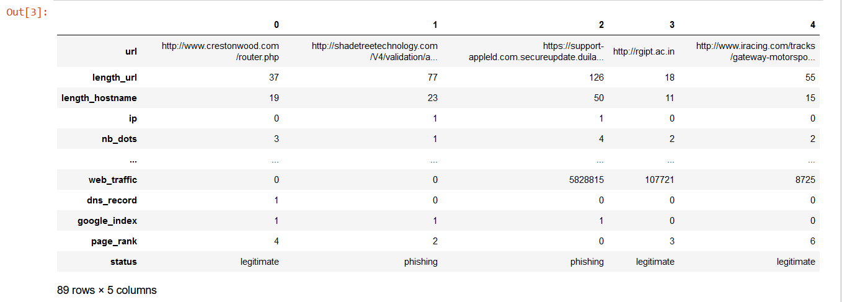

Dataset has 88 features and well labelled. Target column is ‘status’ where websites are labelled ‘phishing’ or ‘legitimate’

Model:

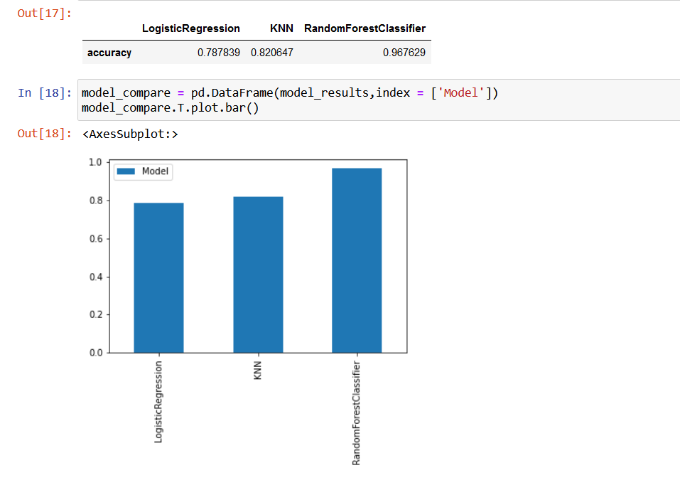

RFC model was used to outperforming other algorithms.

Explanation:

